**COMPUTER NETWORKS**

**NAME: M.ISTAFA MALIK**

**ROLL: P190033**

**SECTION: BSCS-5A**

Task: DNS server configuration in Packet Tracer

Solution:

Step 1: Topology

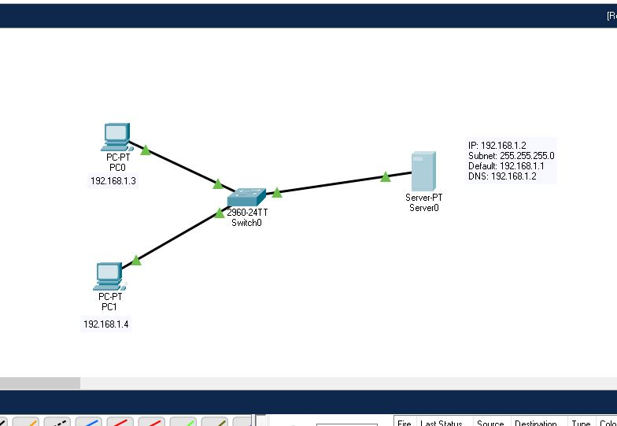

Step 2: Configure Both PC’s with the given IP’S

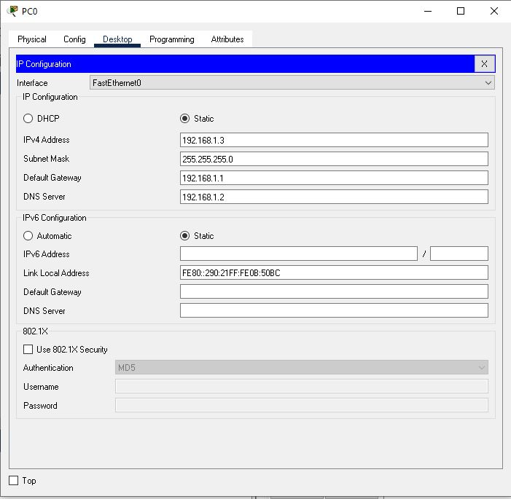

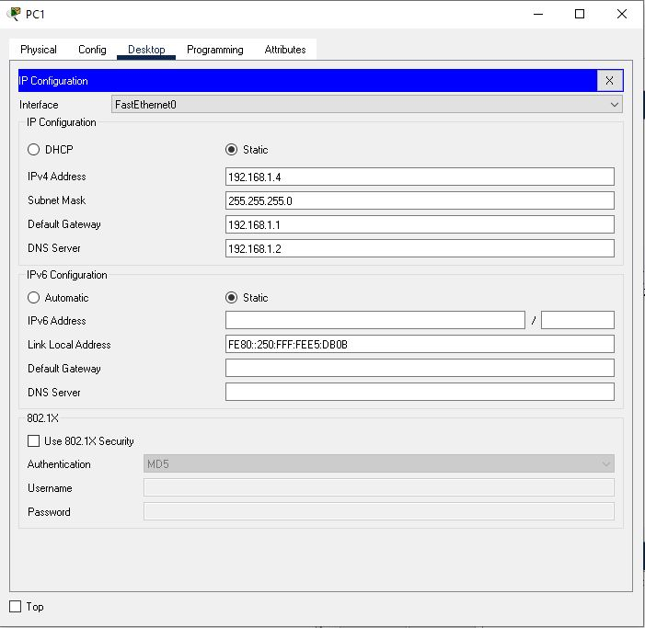

Step 3: Configure DNS Server like shown below

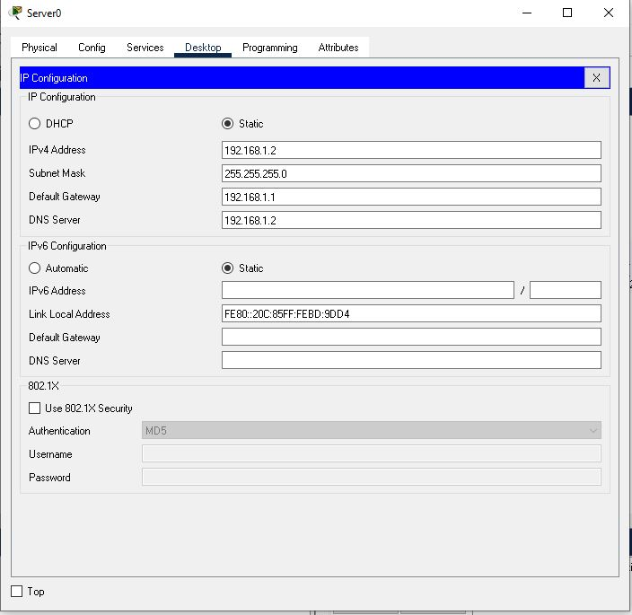

Step 4: Click on DNS, then on to services and turn it on

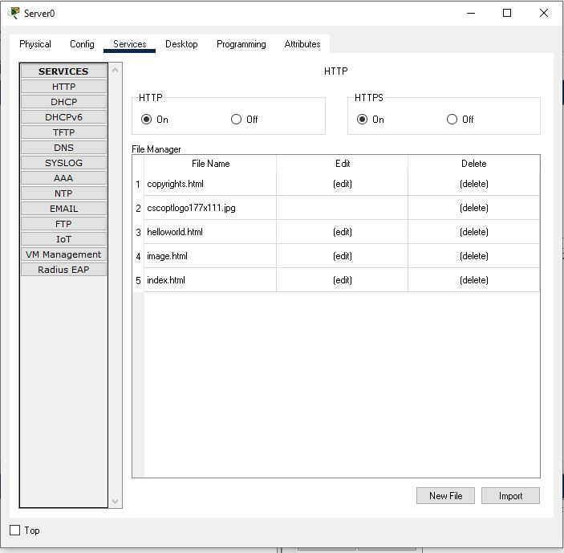

Step 5: Now add both PC’s IP addresses and name.

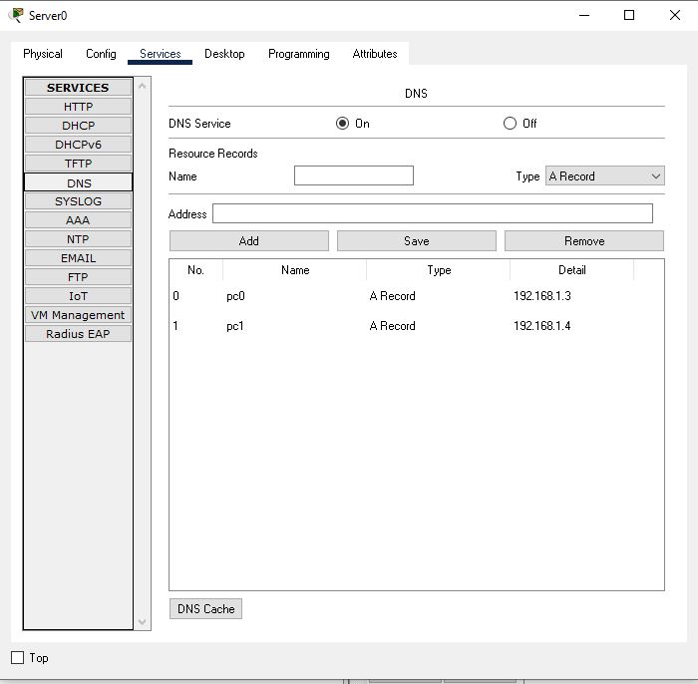

Step 6: Now test your network by sending packets or by using ping command.

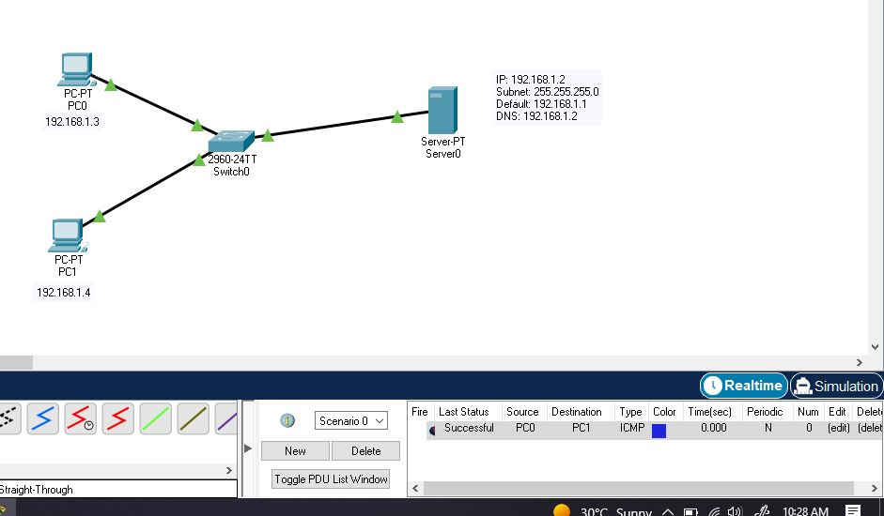

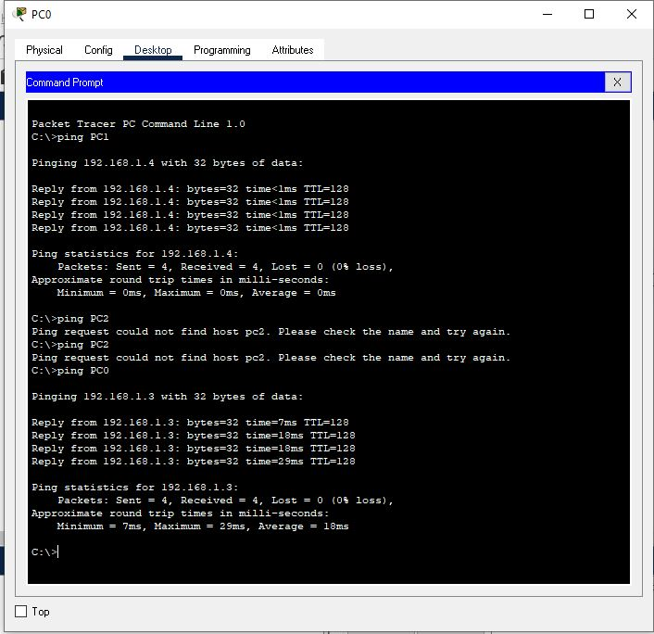

Task: Configuring DHCP server on a Router

Solution:

Step 1: Topology

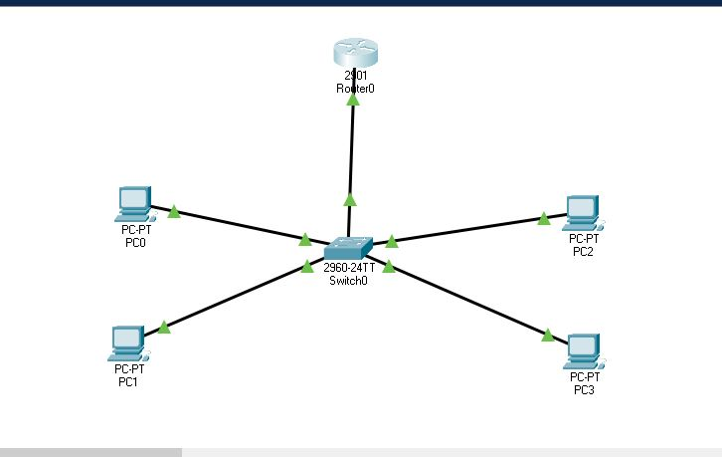

Step 2: Configure Router as shown below

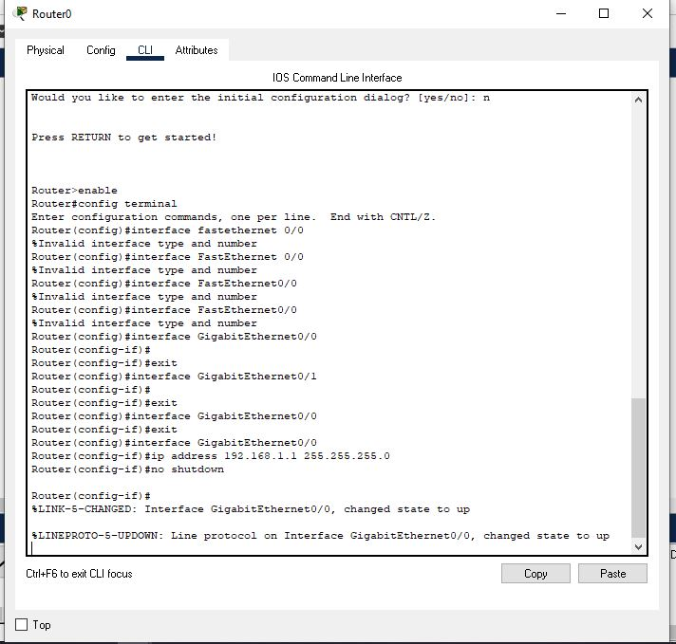

Step 3: Now configure DHCP POOL 1 (P1) using following commands.

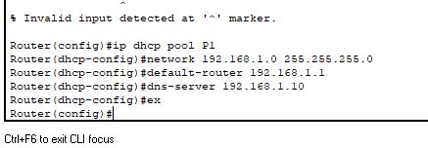

Step 4: Now we will try to assign IP to PC’s through DHCP

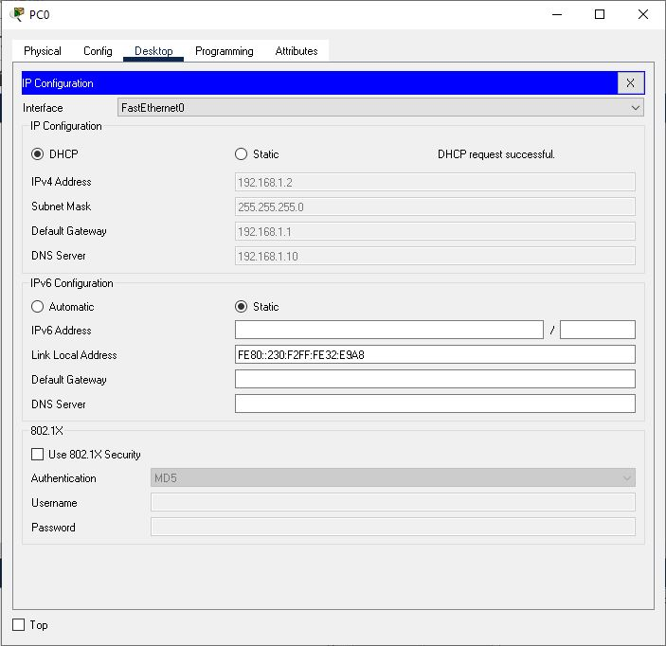

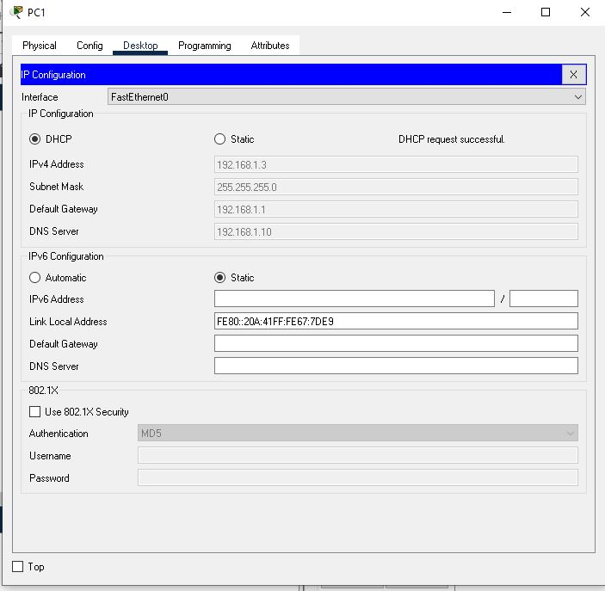

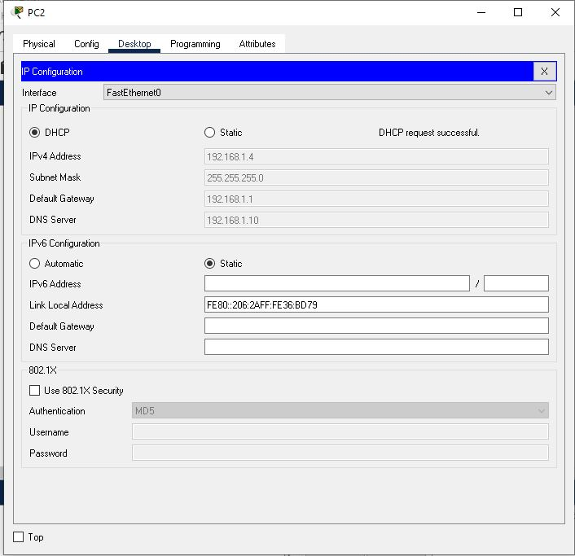

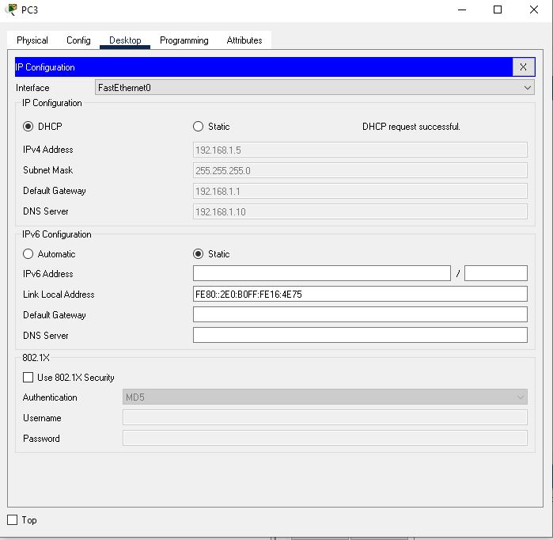

Step 5: Now check by send packet or by ping command.

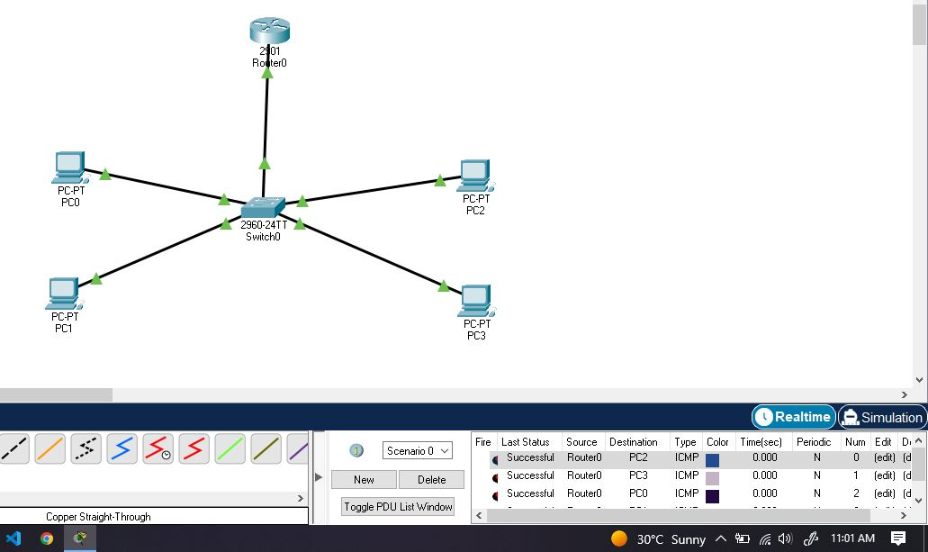

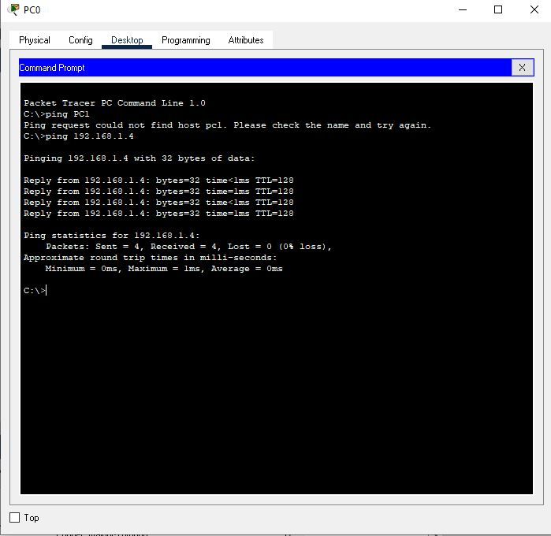

Task: Configuring DHCP service on a generic server

Solution:

Step1: Topology

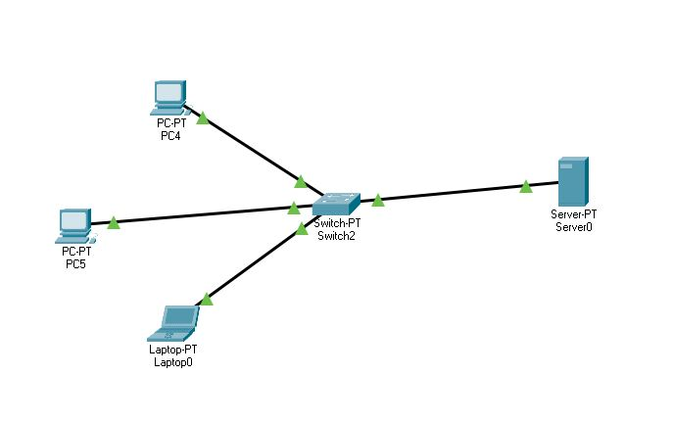

Step 2: Assign IP to the server and create to pool with your desired name that will assign IP’s to all the PC’s.

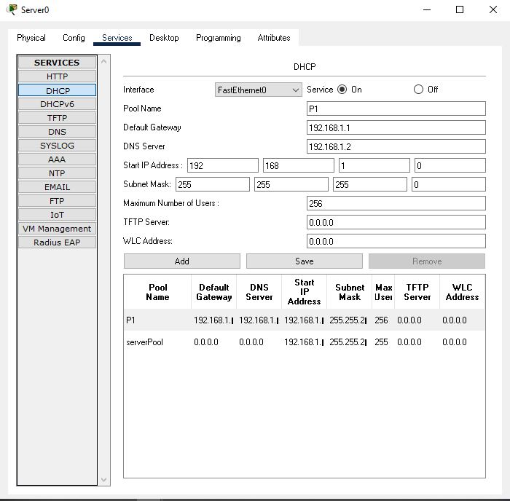

Step 3: Now try assigning IP’s to end devices using DHCP.

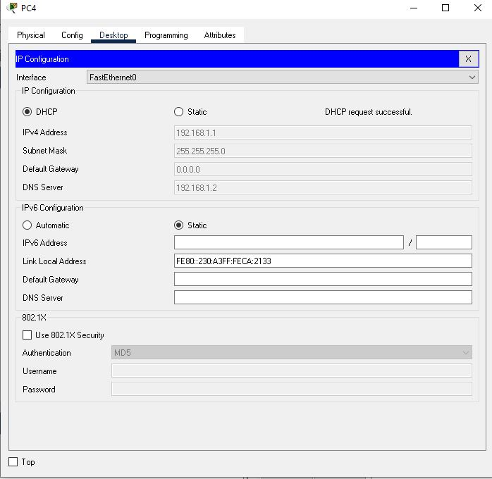

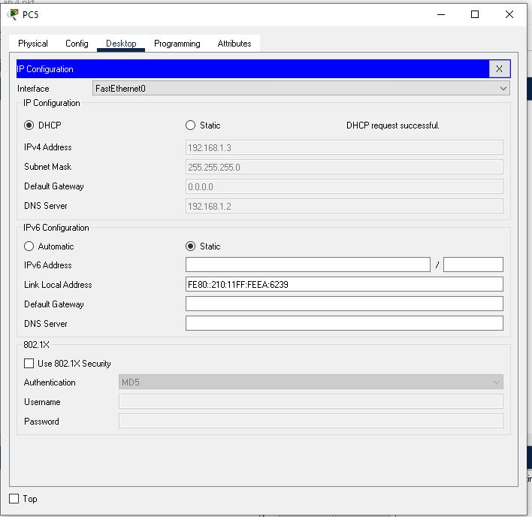

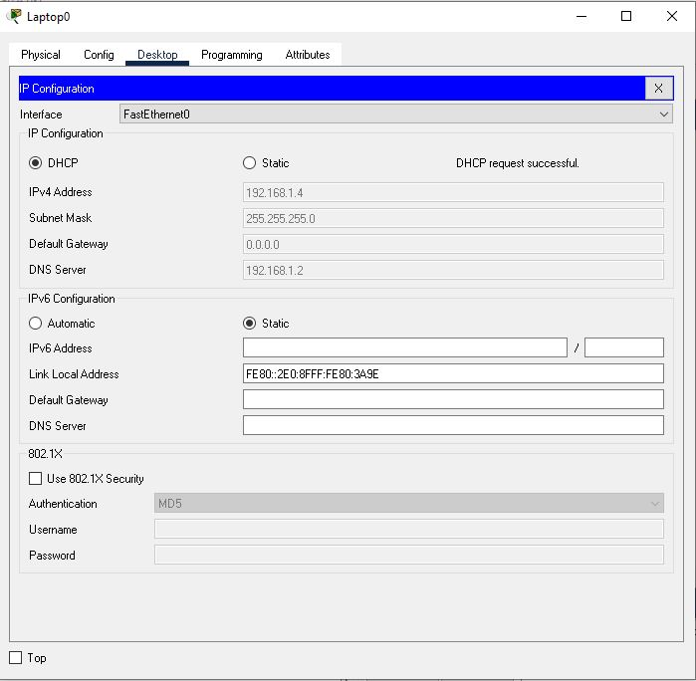

Step 4: Now try it by sending packets or by using ping command.

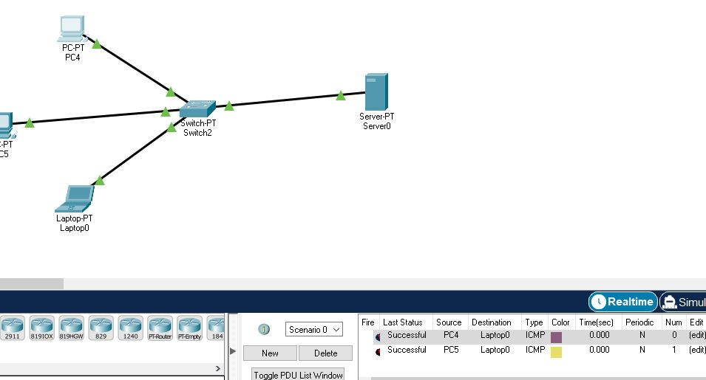

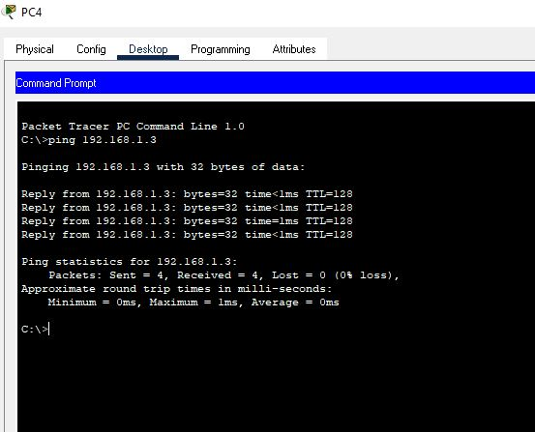

Task: Configuring DHCP, DNS and Web Server configuration in cisco packet trace

Solution:

Step 1: Topology

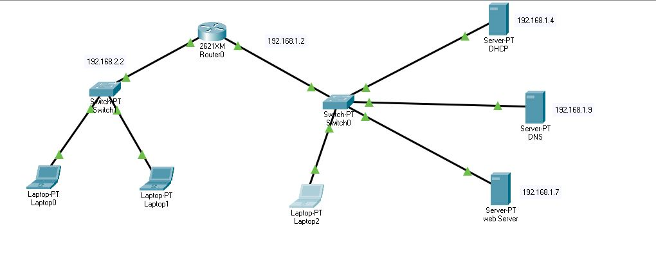

Step 2: Assign Ip address to F0/0 and F0/1 of router

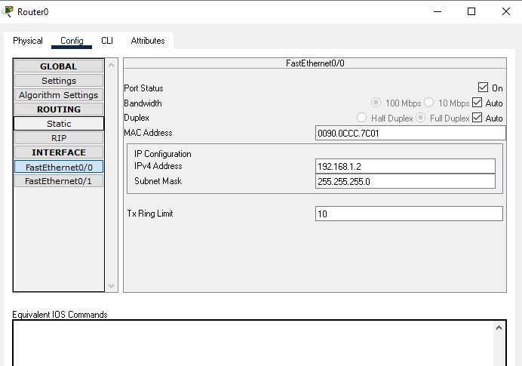

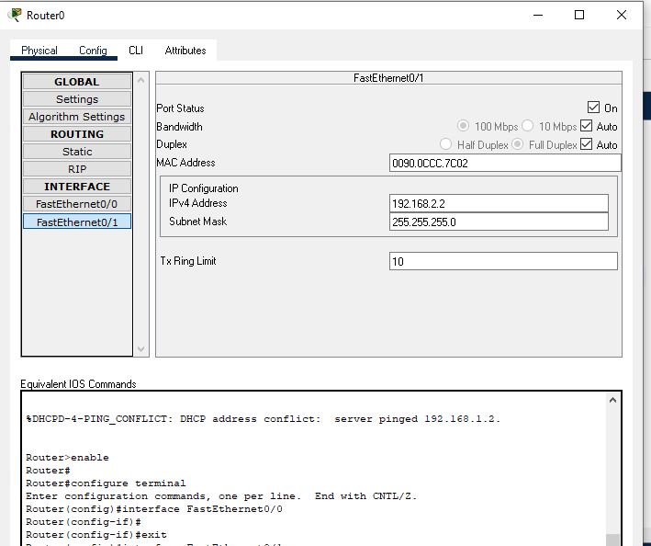

Step 3: Router configuration

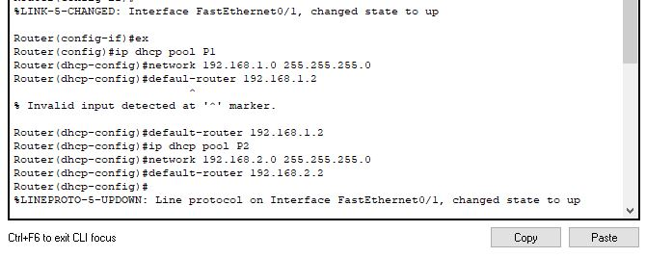

Step 4: Assign static IP to DHCP and Enable DHCP Services and Add Pool P1 and Pool P2 with respective IP Addresses

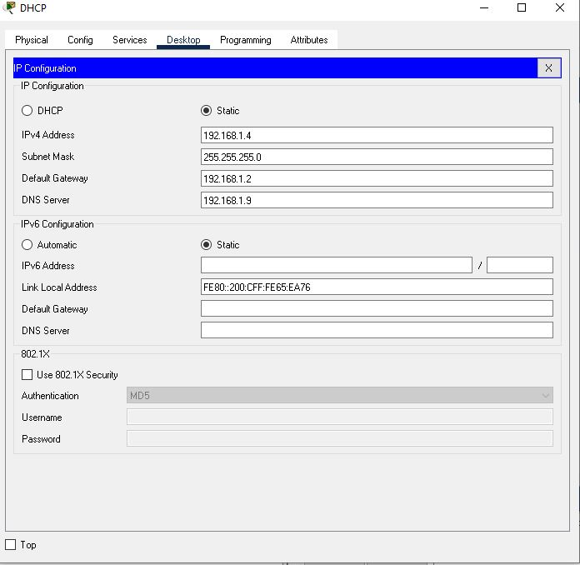

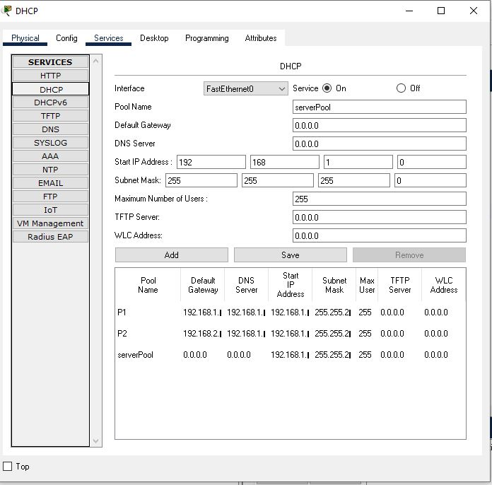

Step 5: Assign Static IP to DNS and Enable DNS Services of DNS and add two resources records.

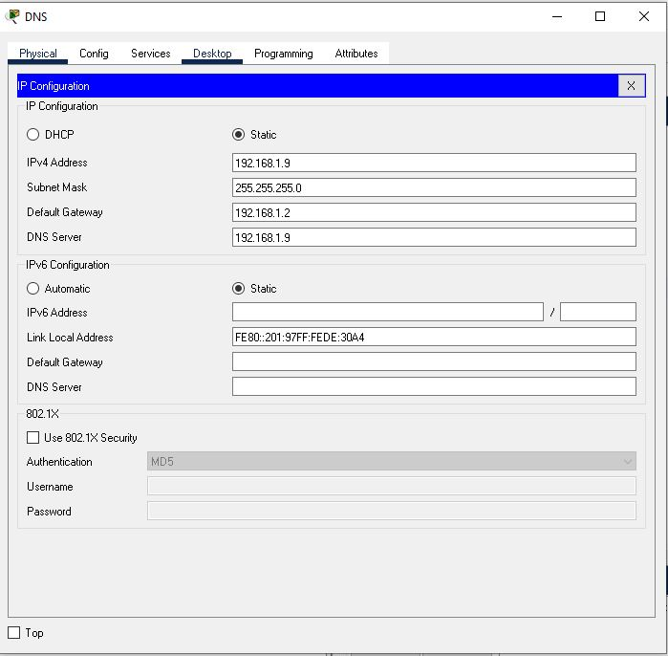

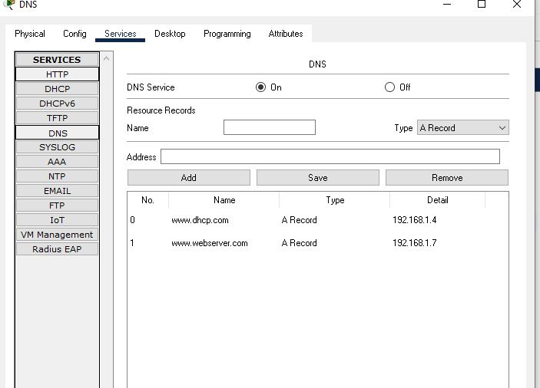

Step 6: Assign static IP to Webserver while also Enable Http and Https in Web Server,edit the index file as you want and save it.

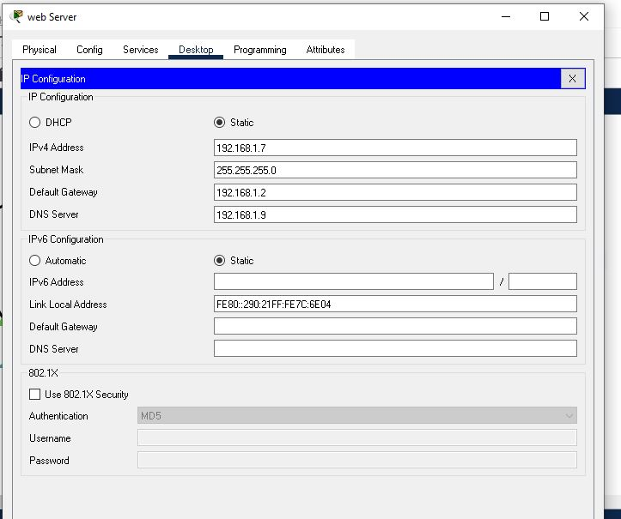

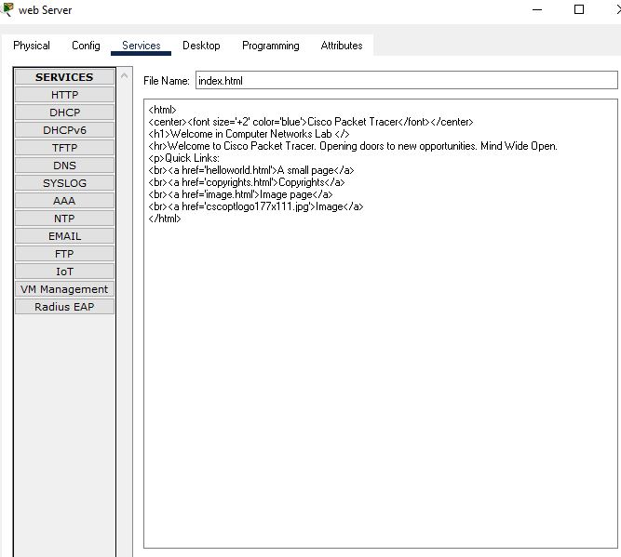

Final Step: Now try assigning IP’s to PC’s using DHCP.

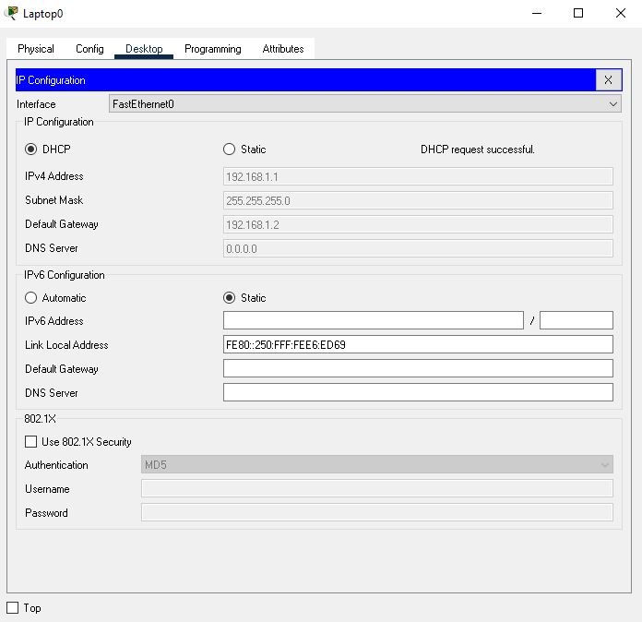

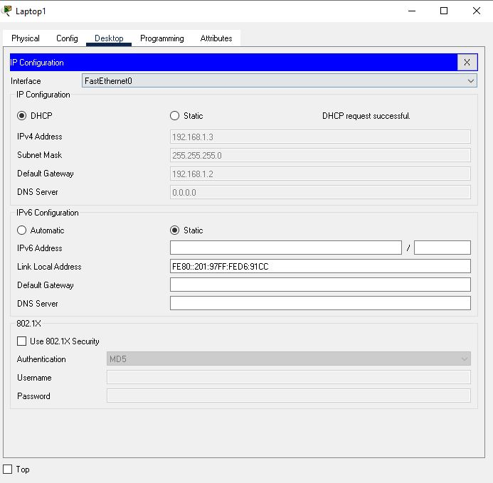

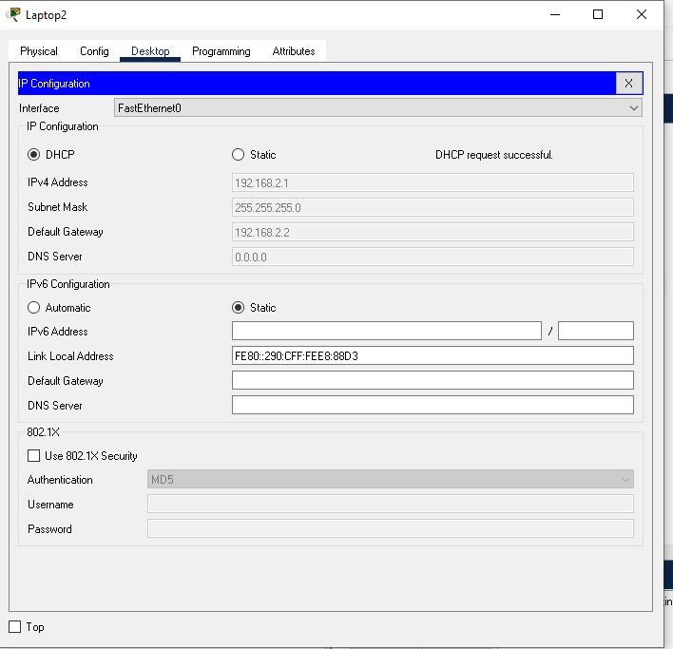

**SUCCESS**